

NOVAC TECHNOLOGY SOLUTIONS

User Manual

Document Version No.: 1.00

Revision History
Version No | Reason For Changes | Author | Approver
0.01 | Draft | Anurag Kumar
1.00 | Reviewed & Approved the User Manual | Anurag Kumar | NIJANTHAN PL

Table of Contents
1. Introduction 4

2. Document upload for VAT exempt 4

Introduction

As per the requirement, System should have the provision to collect document in Proposal and Endorsement screen.
- Guidelines, circulars, instructions and directions released from time to time by Philippines Insurance council.

Document upload for VAT exempt
- System should have the provision to upload the document in the proposal / endorsement during the VAT exempt. In the proposal entry, if user click the VAT Exempt check box then system should mandate the document upload.
- For Motor Fleet, System should have the document upload option against the Master policy and VAT exempt endorsement for Master policy. (Not applicable for child policy).
- System should raise the error message as “Please upload the VAT Exempt certificate” if user select the VAT exempt check box. System should not allow to proceed further without VAT Exempt certificate if VAT exempt check box selected.
- VAT exempt upload is not applicable for the “Inward Facultative” and “Inward Facultative Foreign” business type.
Kindly select the Menu name S0523-Document Search screen
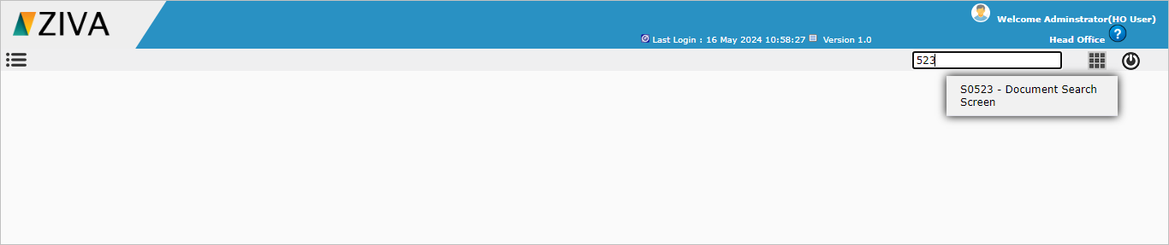

Document Search screen dashboard
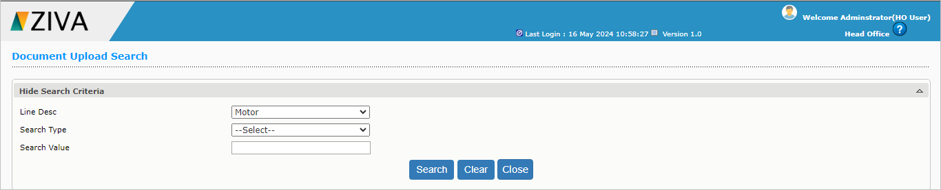

Enter the details as shown in the below image and click on Search Button. System will display the Documents uploaded against the Policy/Endorsement if any.
Also, you can download the uploaded document by clicking on the download button.

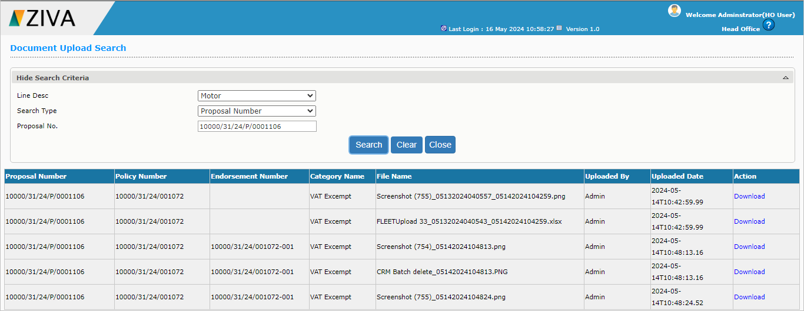

Click on the clear button to clear the search value.
Now click on the close button to close the Document search screen.

